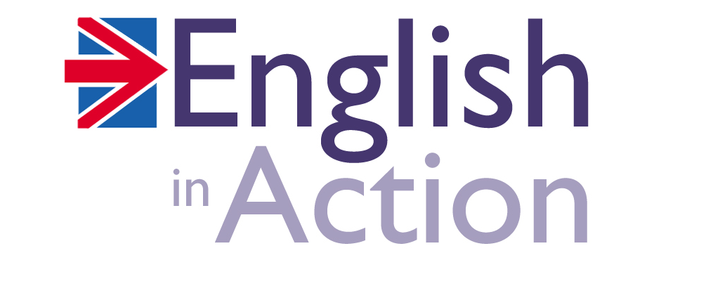

Profile

James Kitch

James attended Aberdeen University where he achieved a BA in Foreign Languages. He later went on to teacher training with Pilgrims, Canterbury. His approach to teaching has always revolved around the benefits of communicative activities and the psychology of the student.

Having taught in Egypt, Bulgaria, Spain, Israel and France, he returned to the UK and started teaching full-time at Stafford House College based in Canterbury in 1995. After a number of years successfully training international students for British exams and University placement, he joined the English in Action team and worked on the development of the ‘EiA’ methodology.

He has since represented EiA in Japan, China, Korea, Russia, Bulgaria, Kazakhstan, Taiwan, Italy, Spain, France, Poland, Austria and Portugal. He now runs seminars on ‘Activity-based Learning’ in each of these countries, with the British Council, ‘LEND’ (Italy), TESOL and the Cambridge Education Group.

As a learner of languages himself, he understands the frustrations, pit-falls and concerns of the student and has worked to develop English in Action to reflect the strengths, weaknesses and needs of students from all over the world.

